KENCID MOBILITY LTD WEBSITE STRUCTURE
CONTENT + VISUAL STORYTELLING ARCHITECTURE

SECTION 1
HERO SECTION
Content
Africa's Future of Universal Design Mobility Starts Here
Designing Movement for Everyone™
We design, manufacture, assemble and deploy Universal Design mobility solutions that enable every person to move with dignity, comfort, independence and equality.

Visual
Full-width cinematic render:
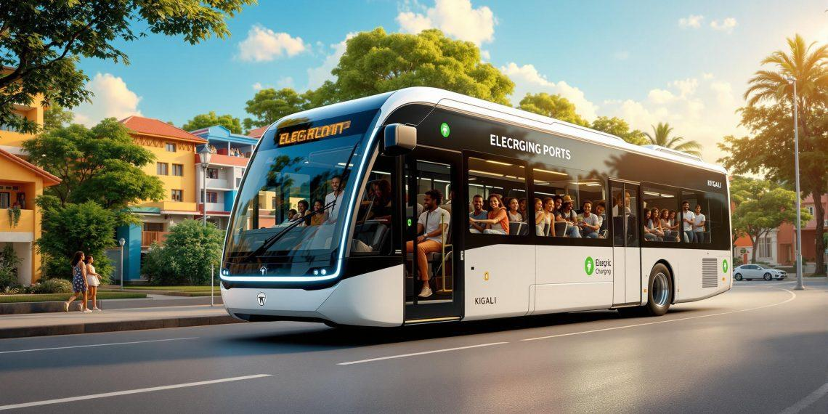
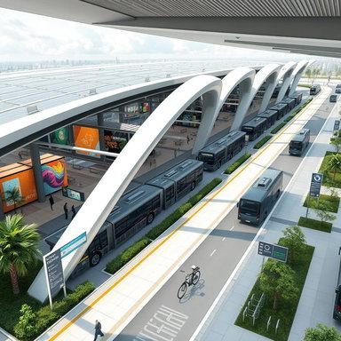
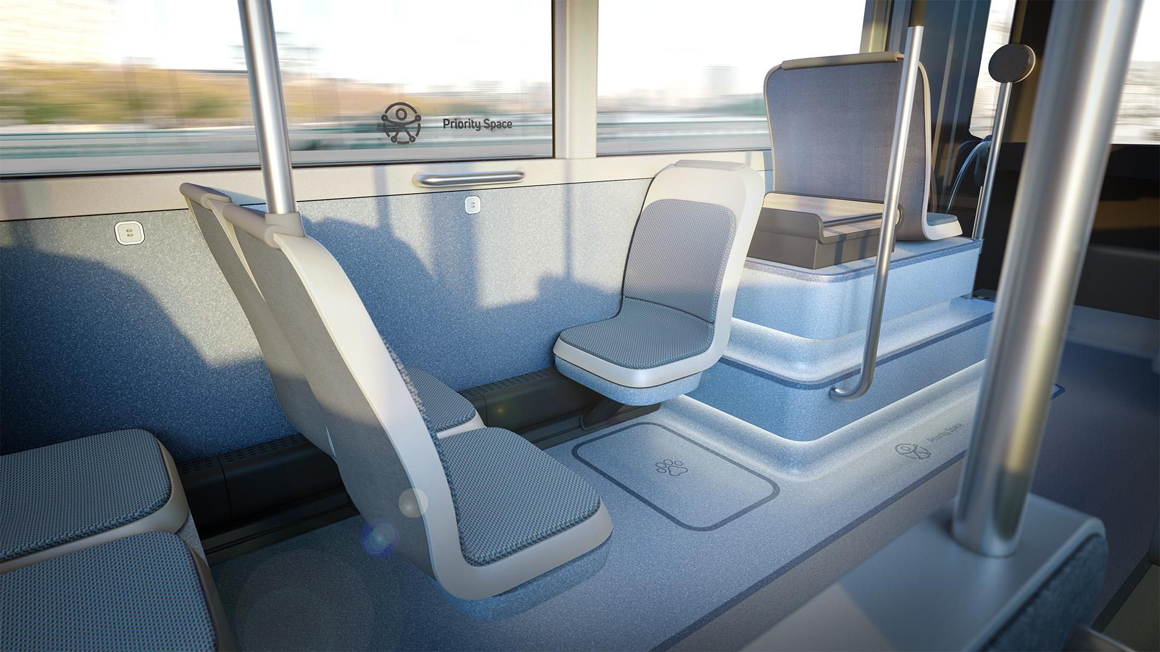
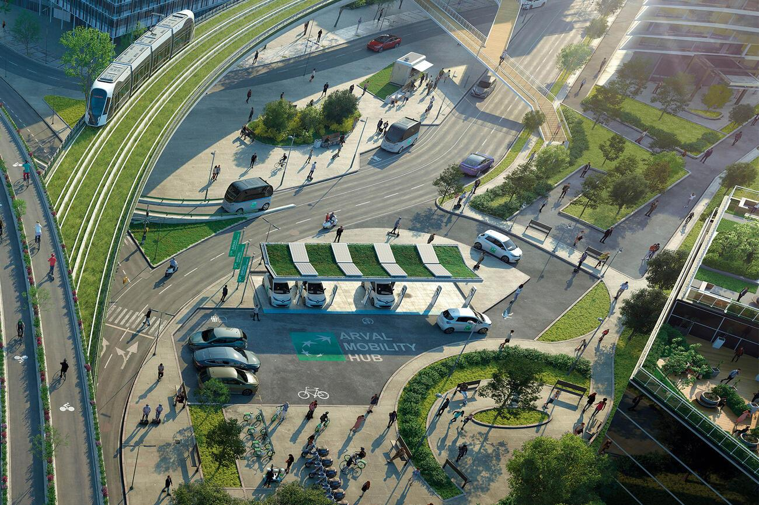
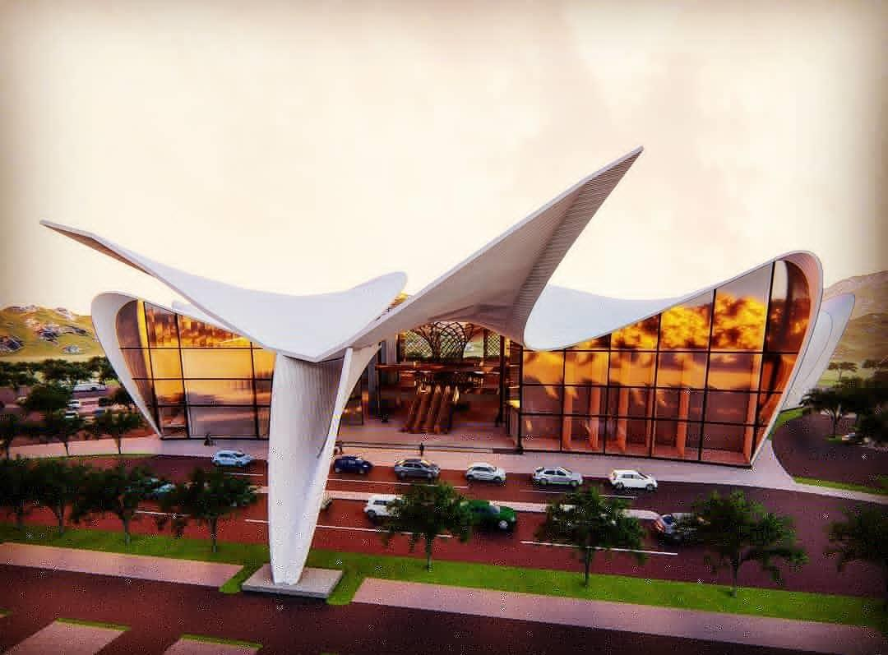
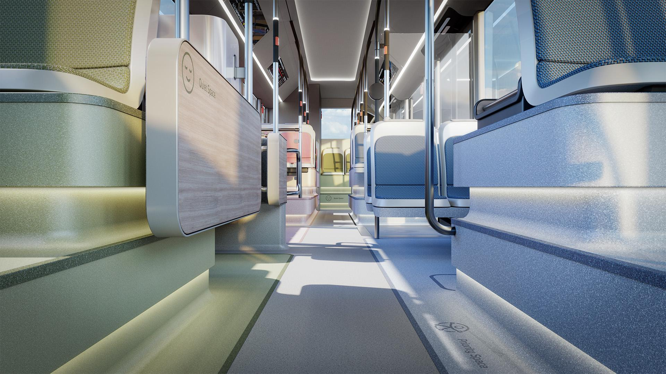
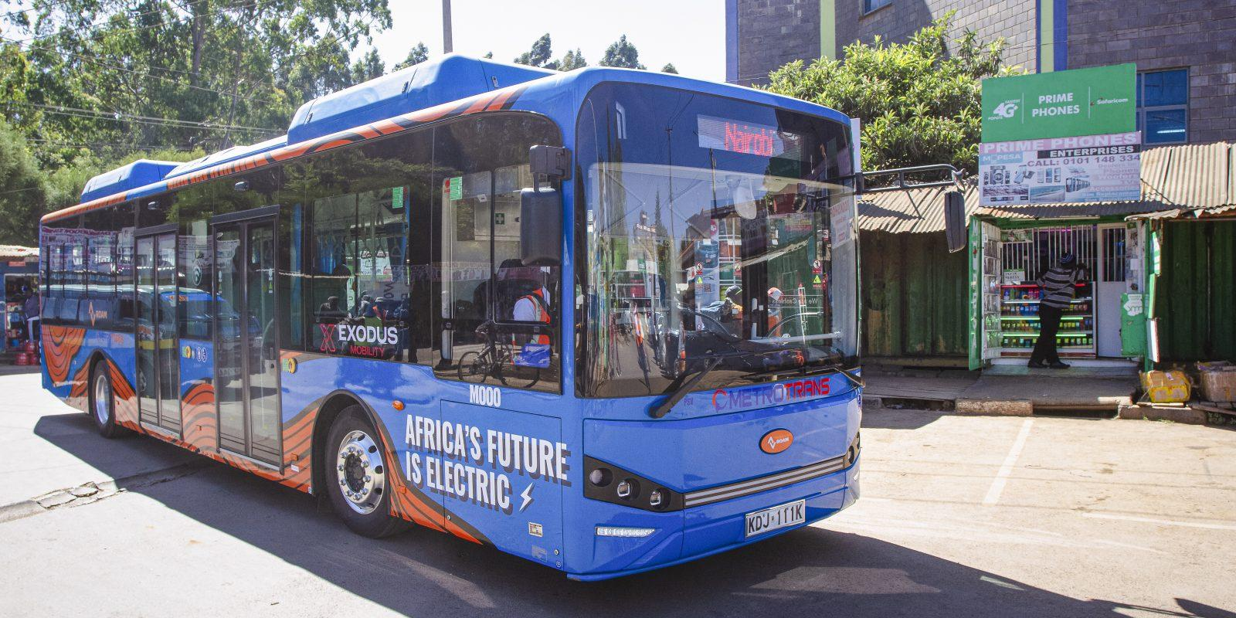
Hero Scene
Show:
- KENCID Universal City Bus
- Modern African skyline
- Foldable seat concept visible through glazing
- Passenger using tactile pathway
- Family boarding comfortably
- Smart digital displays
- Green mobility environment

Interactive Elements
Animated statistics:
100 Million+
Future Passengers Served
50,000+
Universal Design Vehicles
500+
Mobility Hubs
100,000+
Jobs Created

SECTION 2
THE PROBLEM WE ARE SOLVING
Content
Current transport systems were never designed for everyone.
Millions face mobility barriers daily.
The issue is not people.
The issue is design.

Visual
Interactive Problem Infographic
Split screen:
LEFT
Current transport
- High steps
- Confusing information
- Fixed seating
- Poor emergency systems
- Poor wayfinding
RIGHT
KENCID Mobility
- Universal boarding
- Foldable seating
- Tactile guidance
- Smart information
- Multi-sensory communication

Illustration
Passenger journey comparison
Before KENCID
❌ Confusion
❌ Stress
❌ Dependence
After KENCID
✅ Dignity
✅ Independence
✅ Inclusion

SECTION 3
OUR SOLUTION
Content
We create complete mobility ecosystems.
Not just vehicles.
Not just infrastructure.
Entire journeys.

Visual
Large ecosystem diagram
Research
↓
Design
↓
Engineering
↓
Manufacturing
↓
Deployment
↓
Operations
↓
Continuous Improvement

SECTION 4
EXPERIENCE KENCID MOBILITY
This becomes one of the most powerful website sections.

Subsection 1
The Universal Bus Interior
Content explaining:
- Foldable forward-facing seats
- Tactile flooring
- Multi-sensory communication
- Wide circulation

Visual
Large immersive interior render
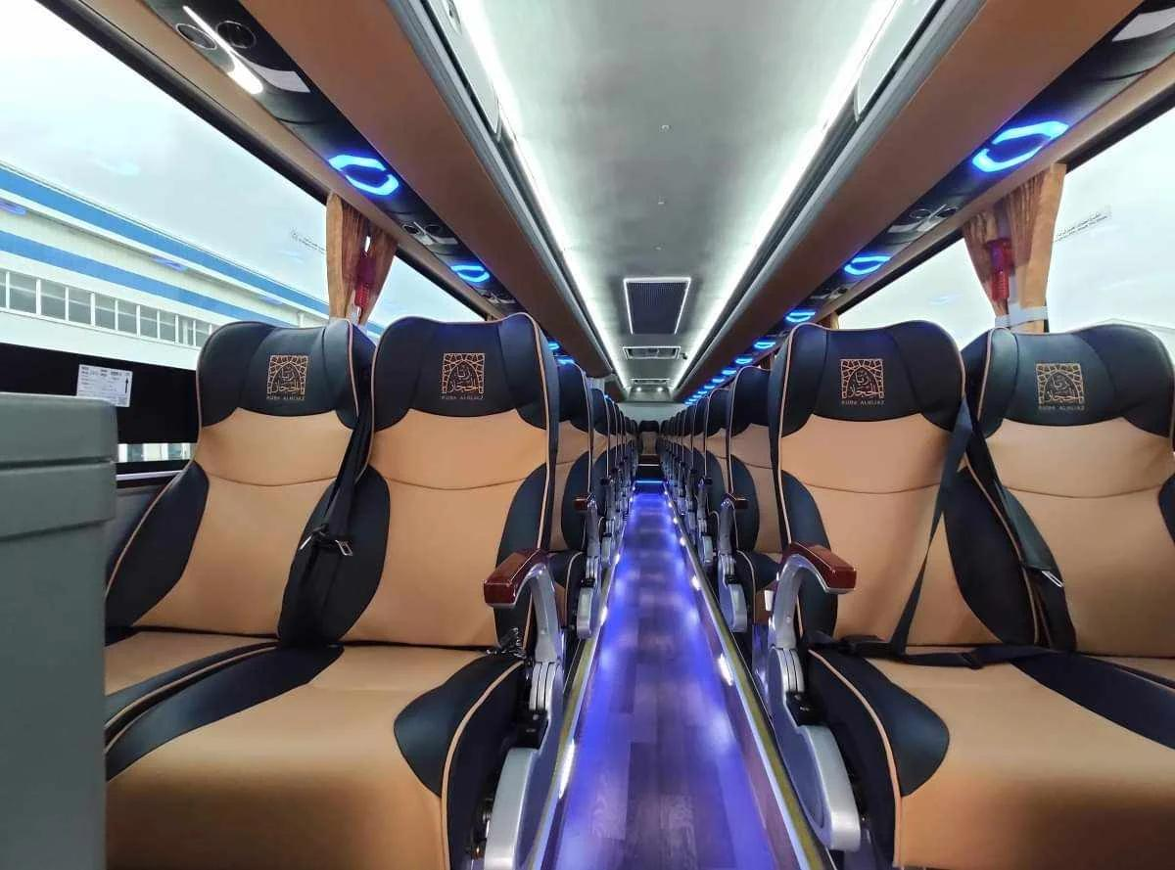
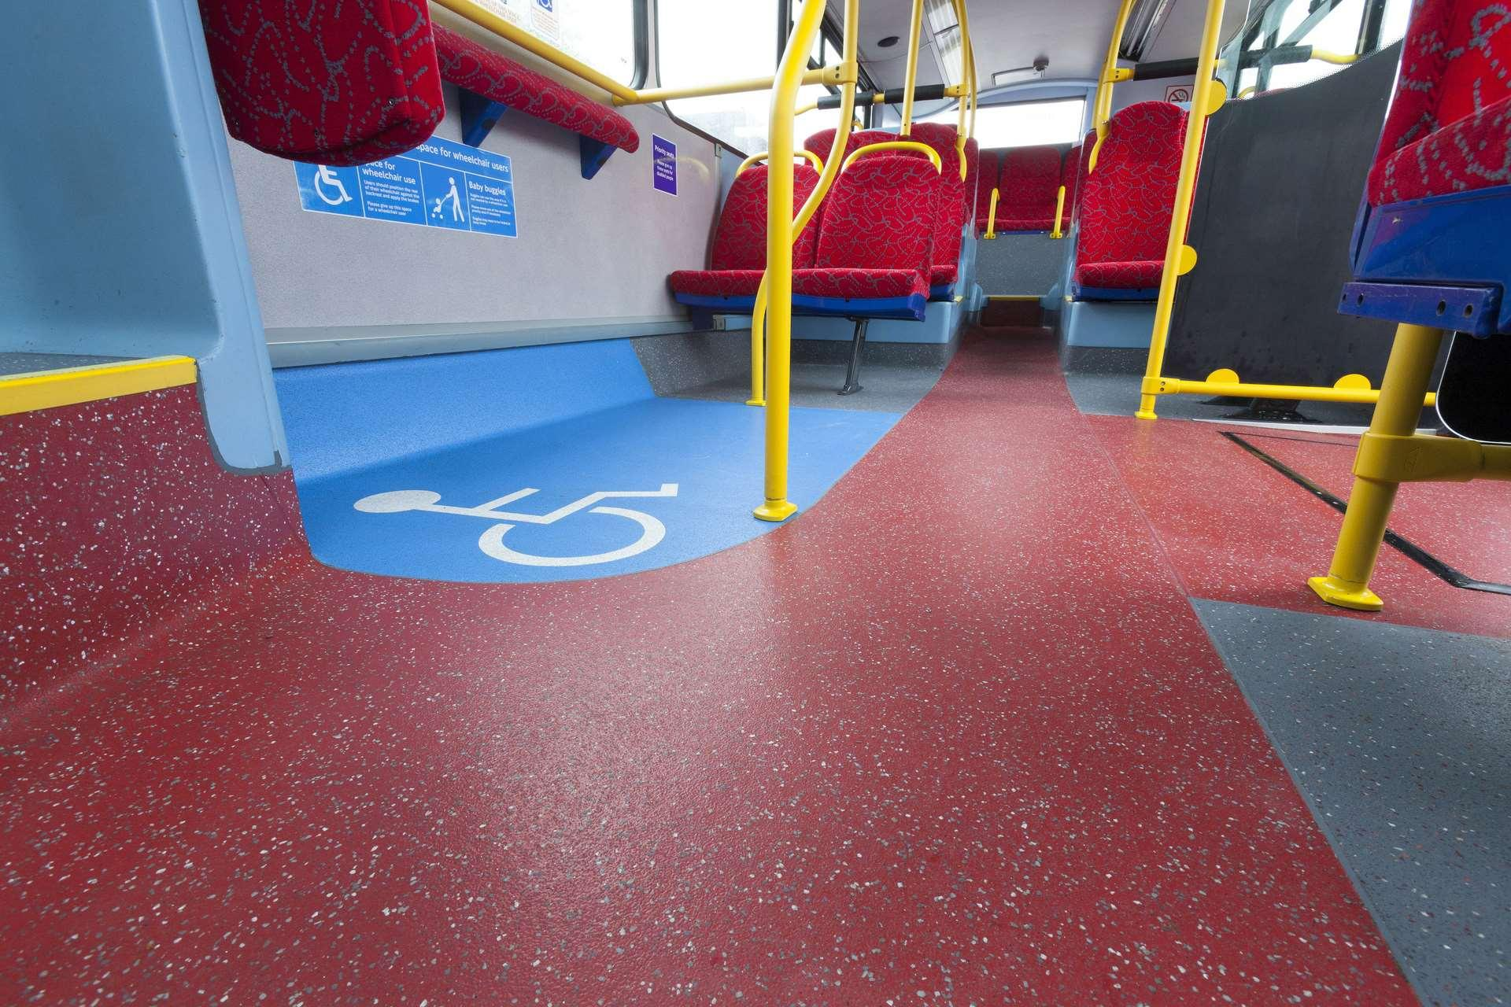
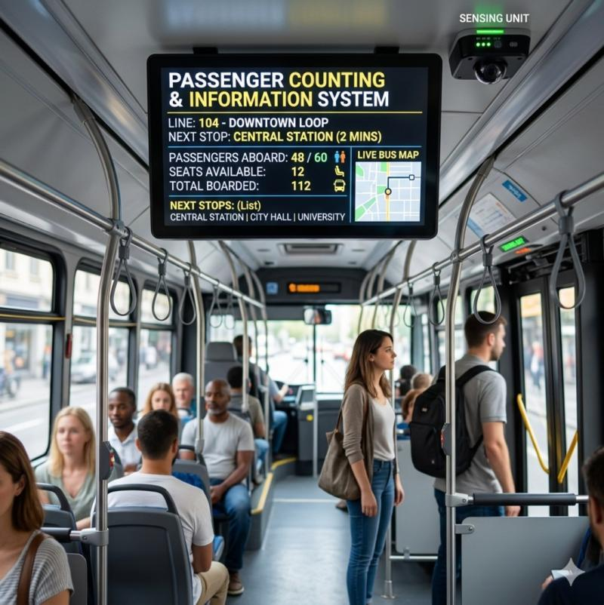
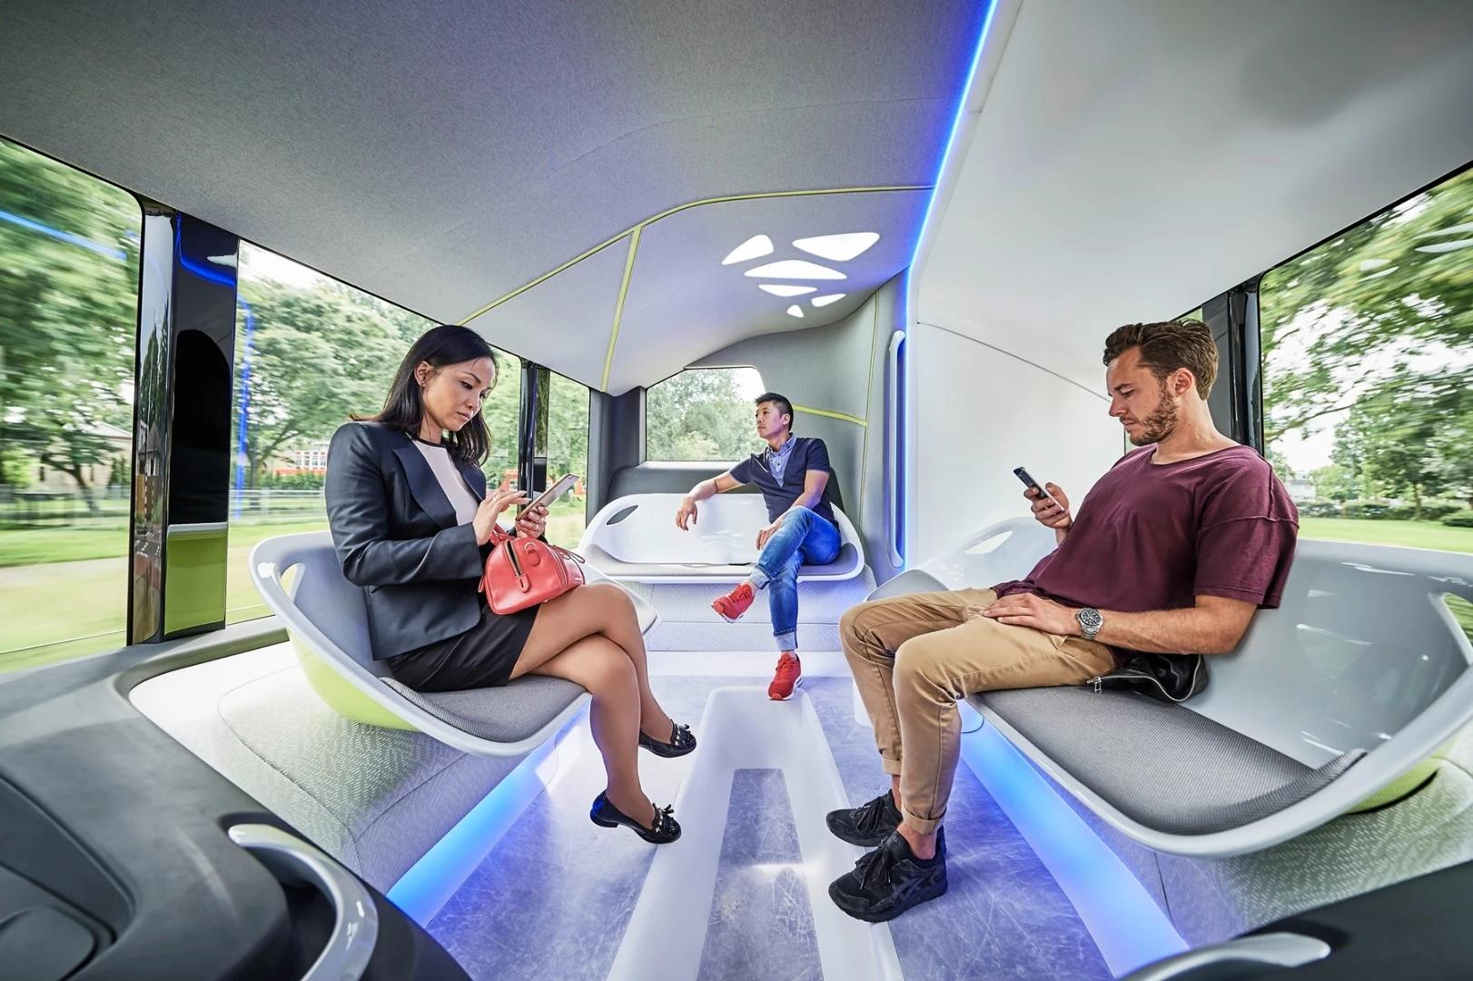
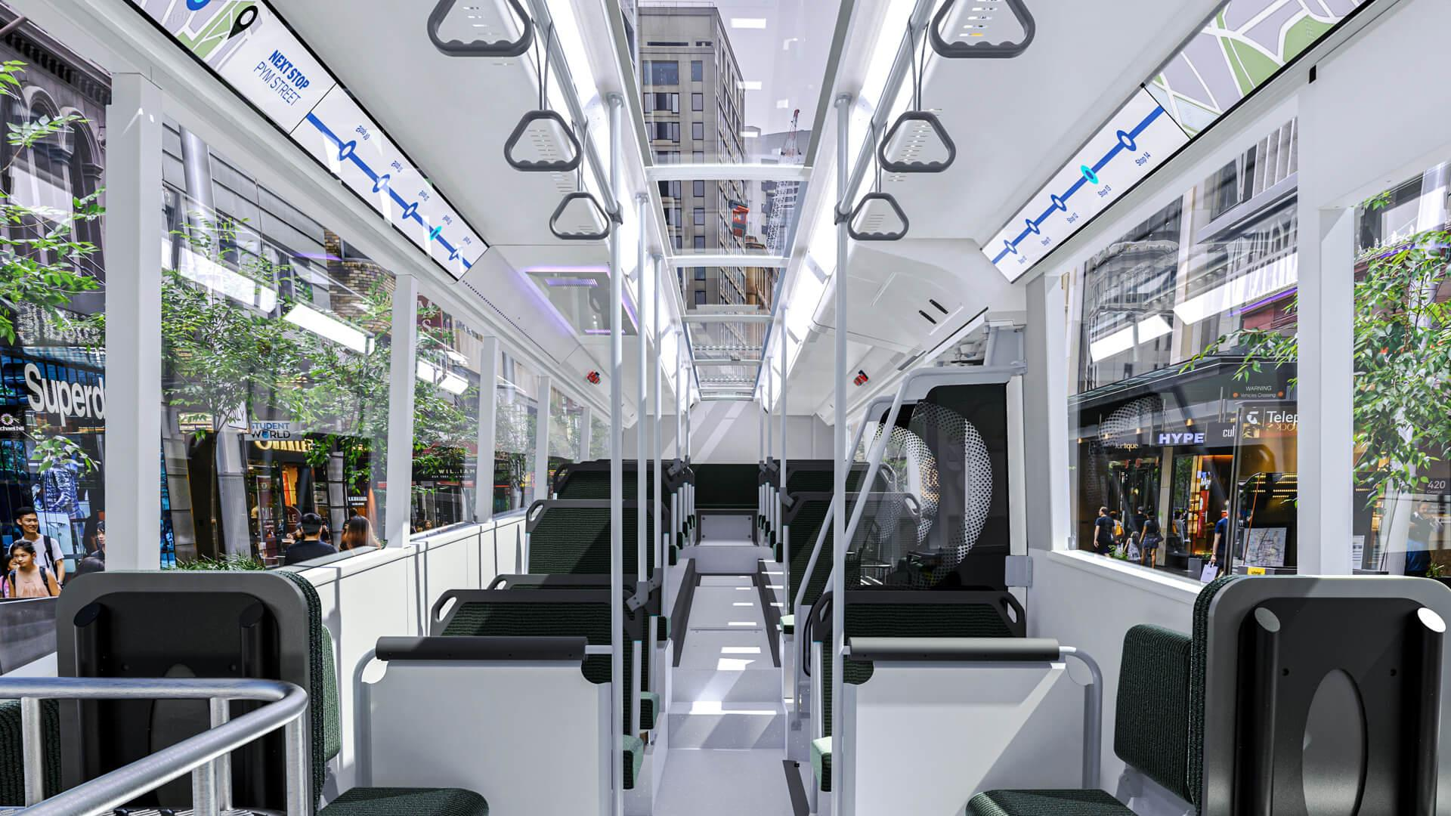
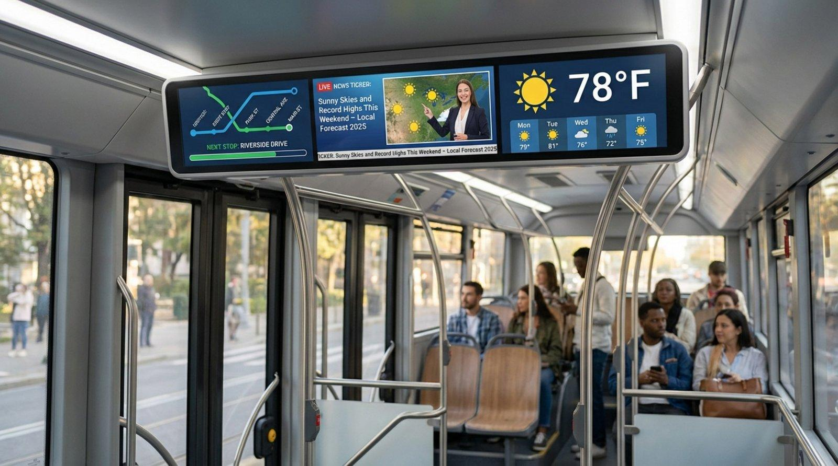
Interactive Feature Hotspots
User clicks:
Seat → explanation
Floor → tactile system
Display → passenger information
Lighting → emergency response

Subsection 2
Universal School Bus
Visual:
Children boarding safely.
GPS tracking interface.
Parent notification dashboard.

Subsection 3
Universal Intercity Coach
Visual:
Premium luxury coach interior.
Flexible seating.
Tourism-focused travel.

Subsection 4
Universal Private Mobility
Visual:
Executive SUV.
Hotel shuttle.
Healthcare transport.

SECTION 5
THE FUTURE BUS TERMINUS
Content
Transport hubs should inspire confidence.
Not chaos.

Visual
Large architectural render
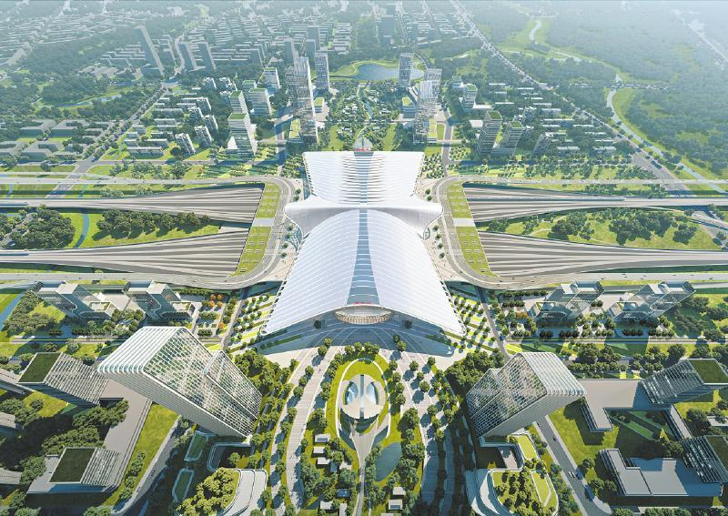

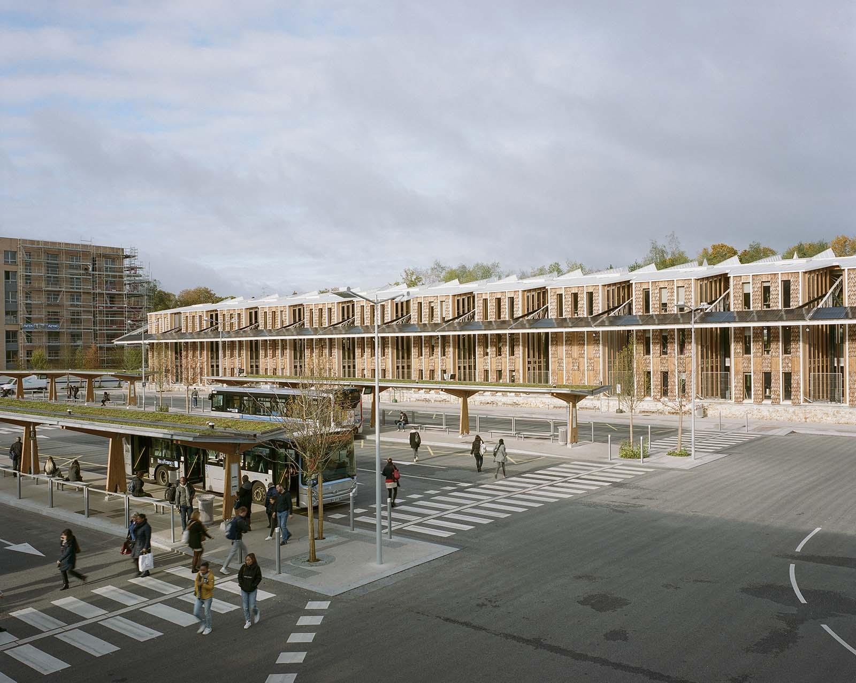
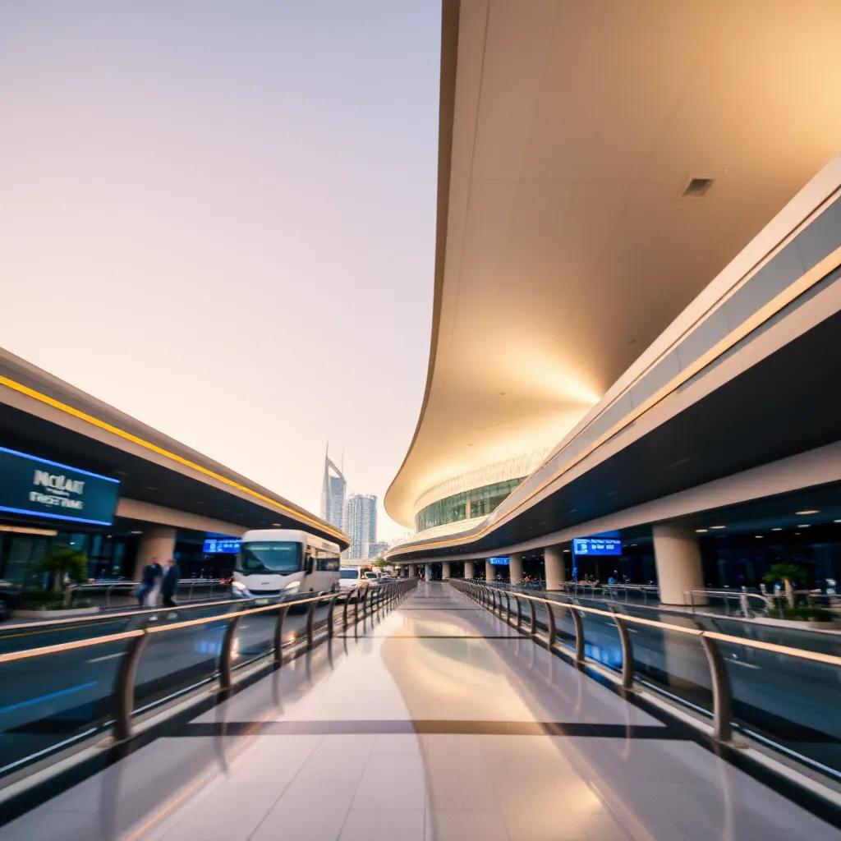
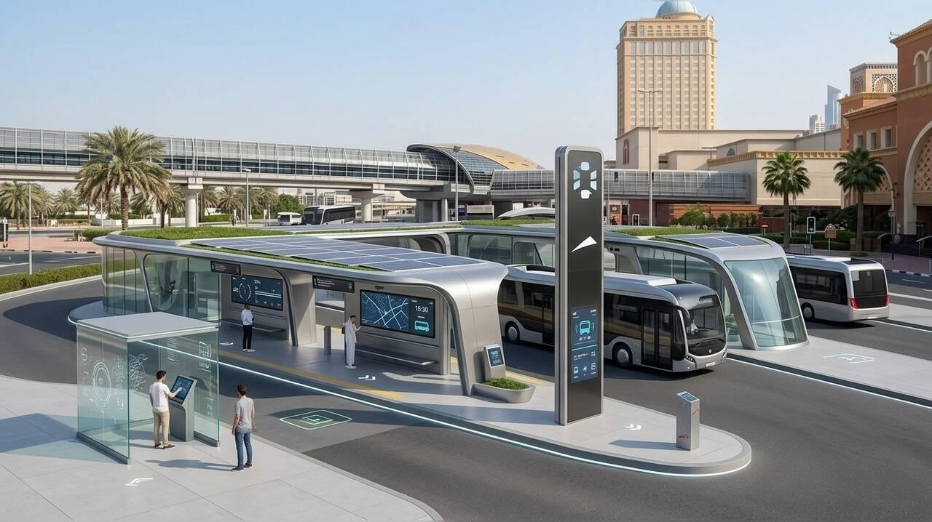
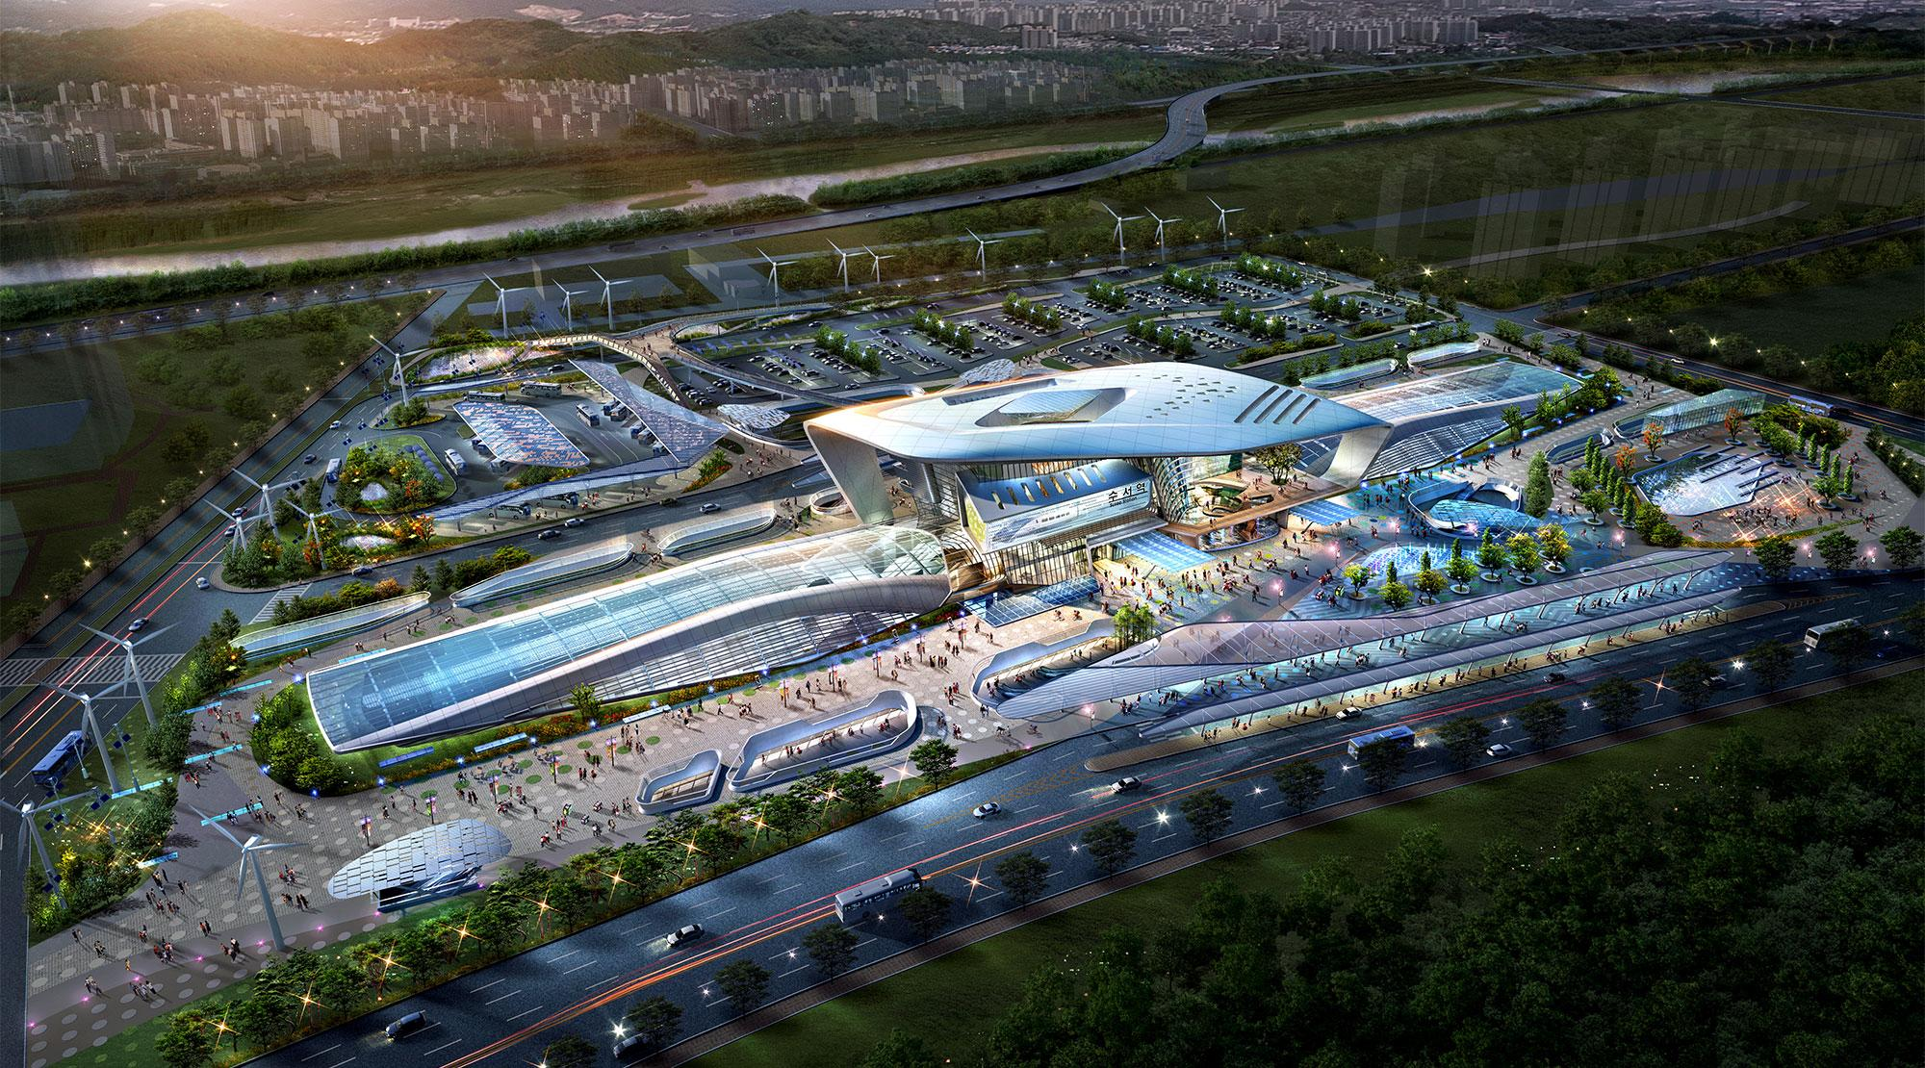
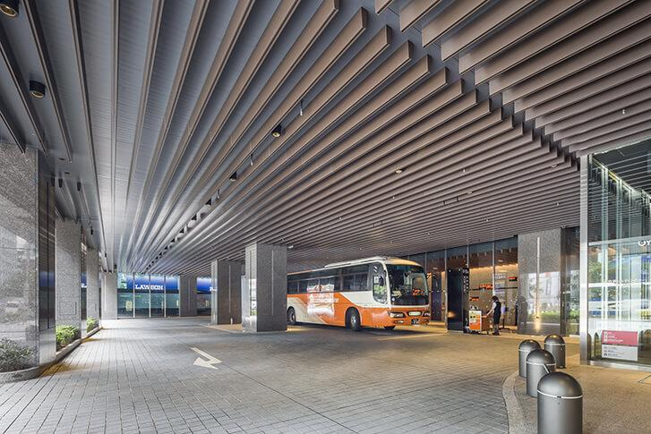
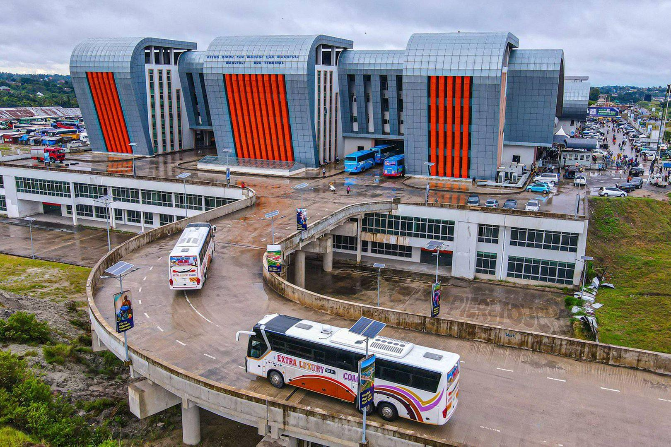

Interactive Terminus Map
Clickable zones:
- Arrival Zone
- Passenger Lounge
- Smart Ticketing
- Retail
- Family Zone
- Universal Restrooms
- Boarding Bays
- Emergency Systems
- Green Areas
- Operations Centre

SECTION 6
SMART MOBILITY ECOSYSTEM
Content
Connecting passengers, operators and cities.

Visual
Central hub graphic
Passenger App
↓
Fleet Dashboard
↓
Operator Console
↓
Smart Ticketing
↓
Data Analytics
↓
Government Planning

App Screens
Show:
- Route tracking
- Ticket purchase
- Emergency support
- Passenger feedback

SECTION 7
ELECTRIC MOBILITY ECOSYSTEM
Content
Sustainable transport for future generations.

Visual
Electric ecosystem diagram
Solar Farm
↓
Charging Hub
↓
Electric Fleet
↓
Smart Grid
↓
Battery Management
↓
Passenger Mobility

Showcase
Electric Bus
Electric Shuttle
Charging Infrastructure
Battery Technology

SECTION 8
MANUFACTURING EXCELLENCE
This should be a signature section.

Content
Africa must manufacture its future.
KENCID Mobility is building African capacity to design, engineer, assemble and export Universal Design vehicles.

Visual
Large manufacturing timeline
Market Research
↓
Concept Design
↓
Engineering
↓
Prototype
↓
Testing
↓
Certification
↓
Manufacturing
↓
Quality Control
↓
Delivery
↓
After Sales

Factory Visual
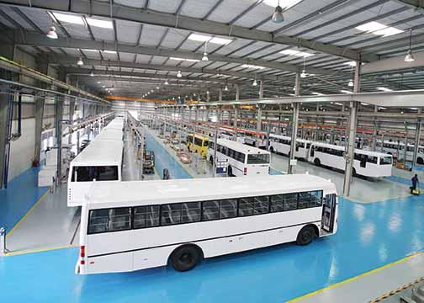
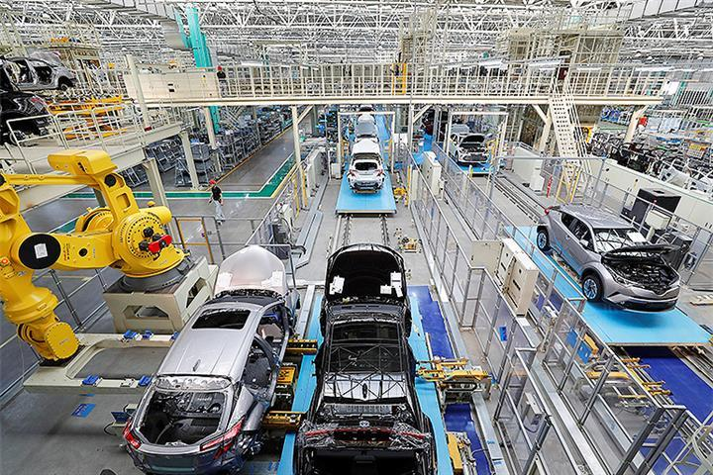
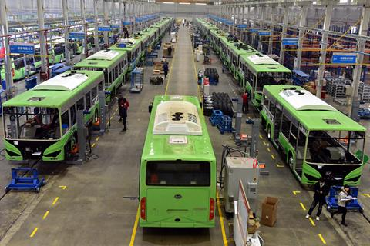
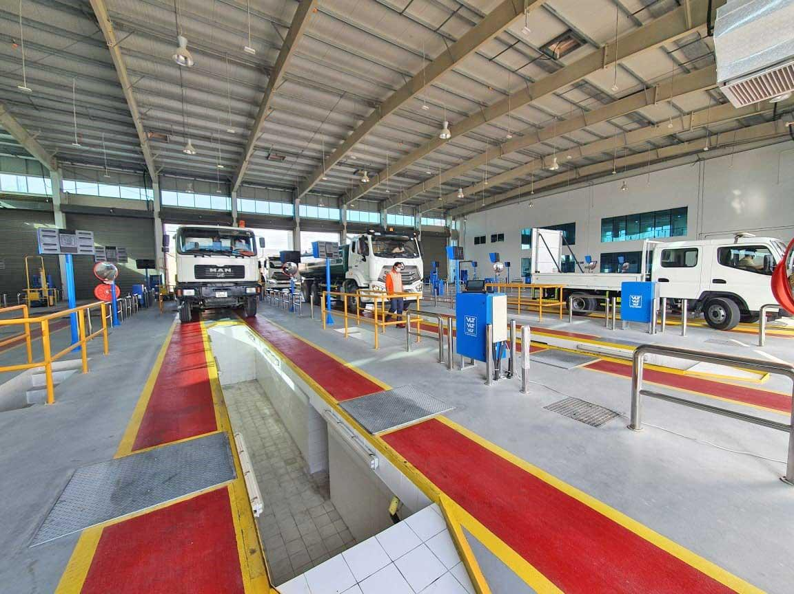
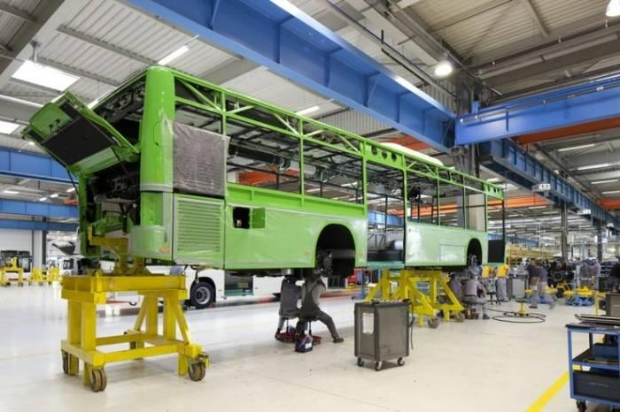
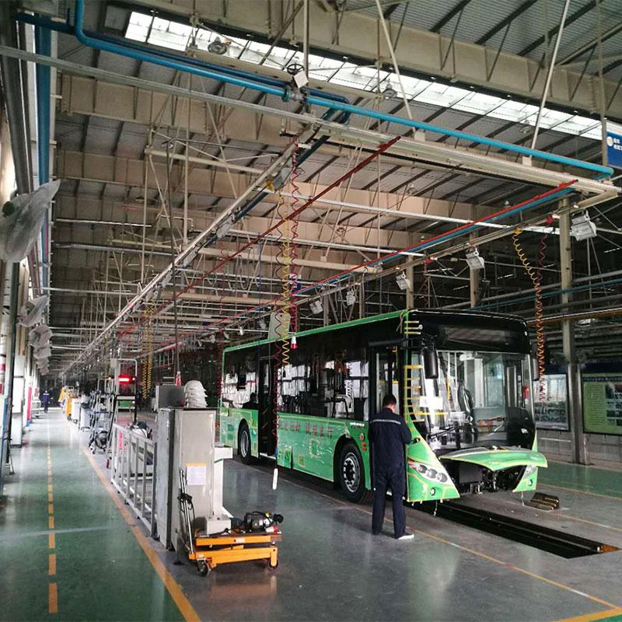

Manufacturing Hotspots
Click each stage:
Research
Concept Design
Engineering
Prototype
Testing
Production
Assembly
Quality Control
Deployment
Support
Each opens detailed content from the manufacturing process section.

SECTION 9
OUR PRODUCTS
Visual product gallery.
Universal City Bus
Large render.
Universal School Bus
Large render.
Universal Intercity Coach
Large render.
Universal Airport Shuttle
Large render.
Universal Private Vehicle
Large render.
Electric Mobility Hub
Large render.
Each links to dedicated product pages.

SECTION 10
RESEARCH & INNOVATION CENTRE
Visual
Research laboratory.
Vehicle simulation.
Testing facilities.
Human-centered design workshop.
University partnerships.

Innovation Pipeline Graphic
Research
↓
Prototype
↓
Pilot
↓
Deployment
↓
Scale

SECTION 11
IMPACT
Visual
Interactive Africa map.
Countries.
Cities.
Vehicles deployed.
People served.
Jobs created.
Carbon emissions reduced.

SECTION 12
INVESTORS
Visual
Investment growth diagram.
Why KENCID?
Universal Design Leadership
Manufacturing Opportunity
Electric Mobility Growth
African Market Scale
Government Demand
Smart Mobility Platform
Social Impact

SECTION 13
PARTNERSHIPS
Visual logos carousel.
Government.
Manufacturers.
Universities.
Technology partners.
Counties.
Operators.
Development partners.

SECTION 14
NEWS & INSIGHTS
Magazine-style layout.
Featured articles.
Thought leadership.
Industry trends.
Research publications.
Case studies.

SECTION 15
CONTACT
Instead of a simple contact form.
Show:
Start Your Mobility Transformation
Government
County
Operator
School
Investor
Manufacturer
Developer
Technology Partner
Each has a dedicated enquiry path.

THE MOST IMPORTANT ADDITION
I would add an entire menu item called:
DESIGN EXPERIENCE
This becomes the flagship section.
Inside:
The Universal Bus
The Universal Terminus
The Universal Passenger Journey
The Smart Mobility Platform
The Manufacturing Process
The Electric Mobility Ecosystem
The KENCID Difference
This is where people emotionally understand the vision.
For investors, governments, and operators, this section will likely be more persuasive than 50 pages of text because it transforms KENCID Mobility from a transport company into a future African mobility movement and manufacturing brand.

